**黄金市场分析与策略 Gold Market Analysis and Strategy**

周二，金价在亚洲交易时段下跌，美元近期走强以及对即将公布的关键通胀数据的预期，使投资者对黄金的需求减少。金价在过去一周内跌至每盎司2,300美元附近的低位交易区间。尽管5月的通胀数据显示出一些价格压力缓解的迹象，但总体上价格压力仍然较大。美国6月采购经理人指数(PMI)出人意料地强劲，这进一步引发了市场对美国经济强劲势头将使利率在更长时间内保持在高位的担忧。高利率增加了投资于非收益资产的机会成本，对金属市场来说是个负面因素。此外，市场对金属产品的情绪仍受到对其最大进口国中国的担忧影响。近期，中国电动汽车面临高额进口关税，使得北京与欧盟和美国爆发贸易战的可能性增加，这加剧了市场的不安。本周市场的焦点是个人消费支出(PCE)价格指数数据，这是美联储青睐的通胀指标。该数据将于周五公布，市场普遍预计通胀将略有降温，但仍会远高于美联储2%的年度目标。

On Tuesday, gold prices fell during the Asian trading session. The recent strengthening of the dollar and the anticipation of key upcoming inflation data reduced investors' demand for gold. Over the past week, gold prices have dropped to a low trading range near $2,300 per ounce. Although May's inflation data showed some signs of easing price pressures, overall, price pressures remain high. The unexpectedly strong June US Purchasing Managers' Index (PMI) has further fueled market concerns that the robust momentum of the US economy will keep interest rates high for a longer period. High interest rates increase the opportunity cost of investing in non-yielding assets, which is a negative factor for the metals market. Additionally, market sentiment towards metals remains affected by concerns about China, its largest importer. Recently, Chinese electric vehicles have faced high import tariffs, increasing the likelihood of a trade war between Beijing and the EU and the US, which has heightened market unease. This week's market focus is on the Personal Consumption Expenditures (PCE) Price Index data, a favored inflation gauge of the Federal Reserve. The data, set to be released on Friday, is widely expected to show a slight easing of inflation but will still be far above the Fed's annual target of 2%.

**技术面分析 Technical analysis**

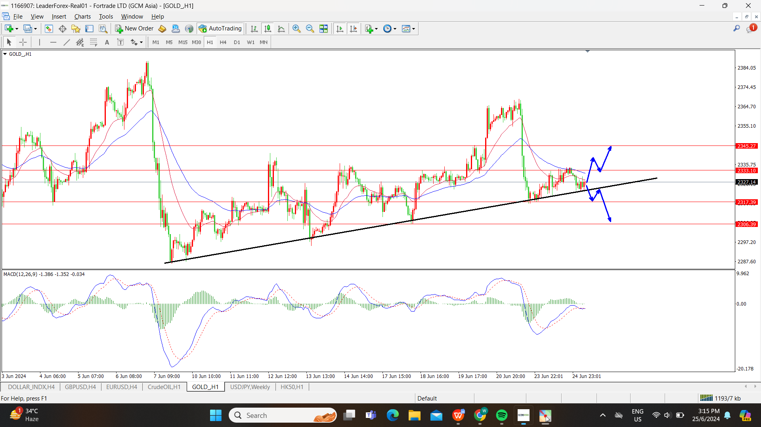

在1小时级别图形来看，黄金价格目前处于震荡行情。而且可以看到MACD指标并没有一个明显的金叉或者死叉信号，更加确定了目前的震荡行情。然而，以价格行为来分析的话，黄金的短期趋势仍偏向多头，主要是因为价格形成了上涨趋势结构，再加上价格接近了下方的上涨趋势线。因此价格有可能在现在的价格（2327附近）开始反弹向上。但是，我们也不排除价格直接跌破2327支撑位的可能性。保守的投资者建议可以先观察价格能否突破关键压力位/支撑位。

On the 1-hour chart, gold prices are currently in a consolidation phase. The MACD indicator does not show a clear bullish or bearish crossover signal, which further confirms the current consolidation. However, analyzing price action, the short-term trend of gold still leans towards bullish. This is mainly because the price has formed an upward trend structure and is near the lower end of the rising trendline. Therefore, the price may start to rebound upwards around the current price (near 2327). However, we also cannot rule out the possibility of the price directly breaking below the 2327 support level. Conservative investors are advised to first observe whether the price can break through key resistance/support levels.

**黄金今日策略 Gold Trading Strategy for Today**

激进的投资者 Aggressive Investors

做多的位置：2327附近，止损：2317附近，止盈：2345附近

Long Position: Around 2327, Stop Loss: Around 2317, Take Profit: Around 2345

稳健的投资者 Conservative Investors

做多的位置：2333附近，止损：2322附近，目标：2345附近

做空的位置：2320附近，止损：2333附近，目标：2306附近

Long Position: Around 2333, Stop Loss: Around 2322, Take Profit: Around 2345

Short Position: Around 2320, Stop Loss: Around 2333, Take Profit: Around 2306

**原油市场分析与策略 Crude oil market analysis and strategy**

周二亚洲交易时段，油价小幅上涨，因市场预期夏季需求会增加，同时对俄罗斯和中东供应中断的担忧也支撑了原油价格。然而，美元相对强势以及市场对美国利率走向的预期限制了油价的进一步上涨。油价近期上涨的主要原因是市场预期随着夏季旅游旺季的到来，需求将有所改善。数据显示，美国库存意外减少，尤其是汽油库存下降，这进一步印证了这一观点。然而，高利率和粘性通胀给美国经济带来的挑战，使得需求的改善存在不确定性。这种情况下，美元走强也限制了油价的涨幅。在地缘政治方面，中东和俄罗斯的持续动荡也让人们担心供应中断。以色列继续对加沙进行空袭，并进一步推进对拉法的地面进攻，与哈马斯的停火前景渺茫。同时，有报道指出，冲突可能升级为与真主党的全面战争。在俄罗斯，乌克兰称已破坏了30多家俄罗斯炼油厂，继续以俄罗斯主要石油生产基础设施为目标。

During the Asian trading session on Tuesday, oil prices edged up slightly as the market anticipated an increase in summer demand, and concerns over potential supply disruptions from Russia and the Middle East also supported crude prices. However, the relatively strong dollar and expectations regarding the direction of US interest rates limited further increases in oil prices. The recent rise in oil prices has been mainly driven by market expectations that demand will improve with the onset of the summer travel season. Data has shown an unexpected decrease in US inventories, particularly a decline in gasoline stocks, further support this view. However, the challenges posed by high interest rates and sticky inflation to the US economy create uncertainty about the extent of demand improvement. In this context, the strong dollar also limited the rise in oil prices. Geopolitically, ongoing turmoil in the Middle East and Russia raises concerns about potential supply disruptions. Israel continues its airstrikes on Gaza and advances its ground offensive on Rafah, with little prospect of a ceasefire with Hamas. Reports also indicate that the conflict might escalate into a full-scale war with Hezbollah. In Russia, Ukraine claims to have disrupted over 30 Russian refineries, continuing to target major Russian oil production infrastructure.

**技术面分析 Technical analysis**

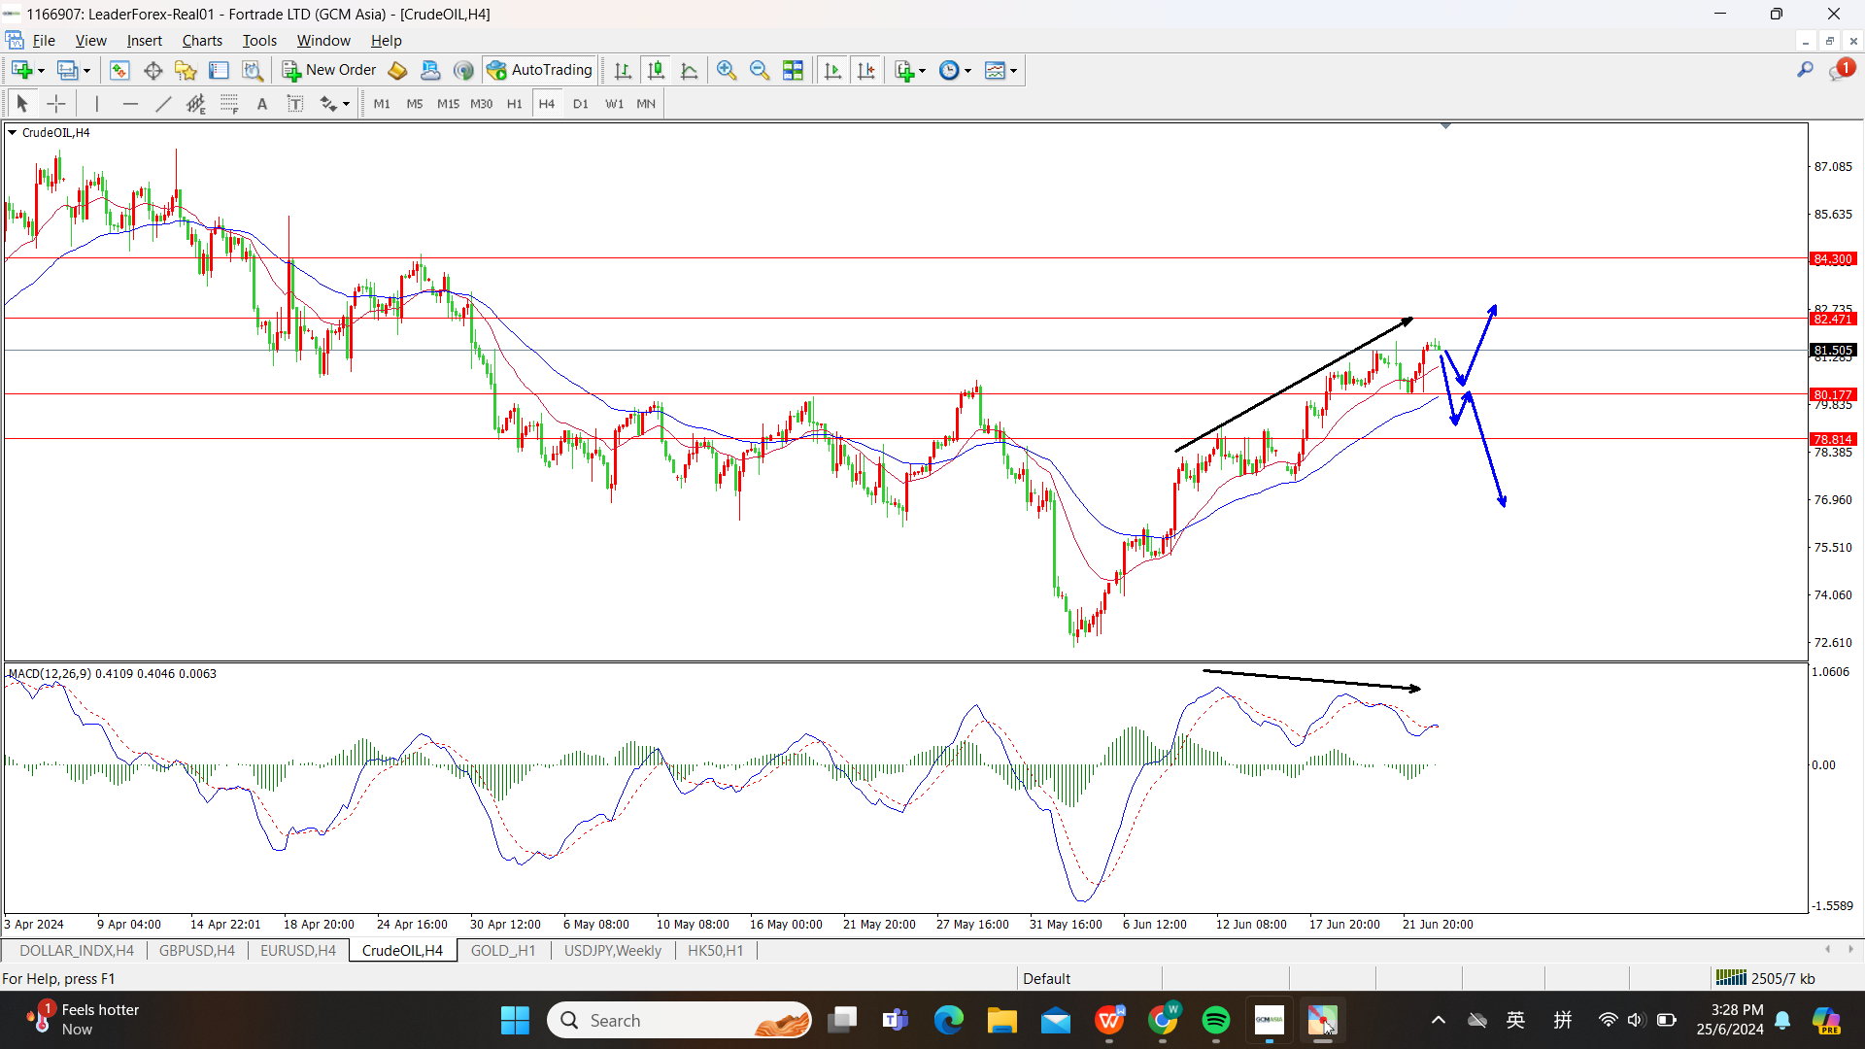

近期原油价格持续突破压力位，震荡上行。然而，根据4小时级别图形来开，可以看到油价的上涨幅度开始减少，MACD指标所显示的顶背离信号证实了这一点，这说明油价有可能在不久的未来迎来大幅度的回调。因为如果根据日线级别图形来看，之前的上涨行情属于第一波行情，因此根据价格行为，回调的概率是比较大的。当然，我们也不能排除价格持续上涨的可能性，因此个人建议可以观望价格是否能跌破近期支撑位。

Recently, crude oil prices have continuously broken through resistance levels and moved upwards in a volatile manner. However, on the 4-hour chart, it can be observed that the upward momentum is starting to weaken. The MACD indicator shows a bearish divergence signal, indicating that oil prices may experience a significant pullback in the near future. On the daily chart, the previous uptrend appears to be the first wave, suggesting a high probability of a pullback based on price action analysis. Of course, the possibility of prices continuing to rise cannot be ruled out. Therefore, it is advisable to observe whether the price can break below the recent support level.

**原油今日策略 Crude Oil Trading Strategy for Today**

激进的投资者 Aggressive Investors

做空的位置：81.55附近，止损：82.00附近，止盈：80.15附近

Short Position: Around 81.55, Stop Loss: Around 82.00, Take Profit: Around 80.15

稳健的投资者 Conservative Investors

做多的位置：80.70附近，止损：80.15附近，止盈：81.90附近

做空的位置：80.15附近，止损：81.10附近，止盈：78.80附近

Long Position: Around 80.70, Stop Loss: Around 80.15, Take Profit: Around 81.90

Short Position: Around 80.15, Stop Loss: Around 81.10, Take Profit: Around 78.80

**恒生指数市场分析与策略 Hang Seng Index market analysis and strategy**

昨日，香港股市上涨，收复近期部分失地，因中欧部长就中国电动汽车进口关税问题展开对话，同时关注即将发布的通胀数据。但市场情绪仍然脆弱，导致恒生指数在今日出现高位回落。此前，中国官员就对中国电动汽车征收新进口关税警告与欧盟爆发贸易战。但投资者关注中国部长们正在与德国官员就可能降低甚至取消关税进行对话。与此同时，加拿大考虑限制中国电动汽车进口，加入美国和欧盟的行列，这可能进一步恶化中国和西方之间的紧张关系。对中国的担忧一直是影响亚洲市场人气的关键因素，尤其是如果中国与其他主要经济体的贸易紧张局势升级。路透社报道称，拜登政府正在调查中国主要电信公司的潜在安全问题，这也削弱了投资者对中国市场的乐观情绪。

Yesterday, Hong Kong stocks rose, recouping some of the recent losses, as China and European ministers engaged in dialogue over the issue of tariffs on China electric vehicle imports, while also focusing on upcoming inflation data. However, market sentiment remains fragile, leading the Hang Seng Index to pull back from its highs today. Previously, China officials had warned of a trade war with the EU over new import tariffs on China electric vehicles. Investors are now watching the dialogue between China and German officials on the possibility of reducing or even canceling these tariffs. Meanwhile, Canada is considering restricting imports of China electric vehicles, joining the US and the EU, which could further exacerbate tensions between China and the West. Concerns over China have been a key factor affecting market sentiment in Asia, especially if trade tensions between China and other major economies escalate. A Reuters report also undermined investor optimism towards the Chinese market, stating that the Biden administration is investigating potential security issues with major China telecommunications companies.

**技术面分析 Technical analysis**

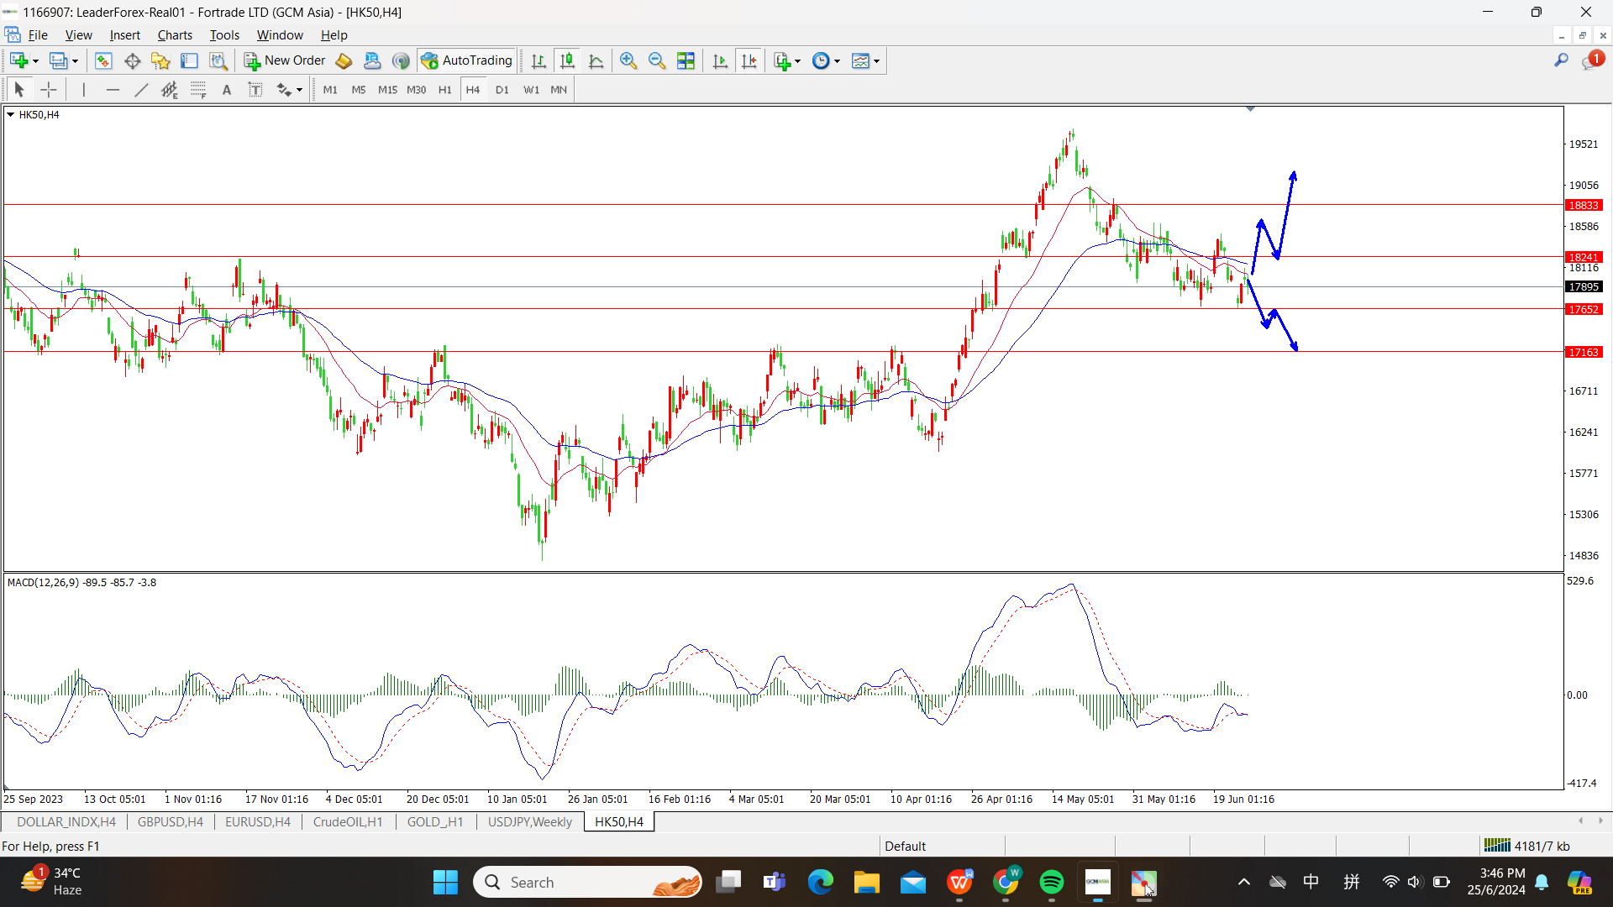

恒生指数目前处于震荡行情，在4小时级别图形来看并没有很明显的交易信号。然而，如果将图标缩小至1小时，就能看到目前的趋势还是以关注空头为主，因为目前的趋势结构还是处于下跌，而且价格并没有突破前期高位。但值得注意的是，价格在前天的下跌行情中，并没有有效的跌破前期地点，说明短期价格有反弹的可能性。因此，个人建议可以继续观望价格的走势，但激进的投资者可以关注空头为主。

The Hang Seng Index is currently in a consolidation phase, with no clear trading signals on the 4-hour chart. However, when zooming into the 1-hour chart, the trend is still primarily bearish, as the trend structure remains downward and prices have not broken through previous highs. Notably, during the recent downward move two days ago, the price did not effectively break below previous lows, indicating a potential short-term rebound. Therefore, it is advisable to continue observing price movements, but aggressive investors may focus on short positions.

**恒生指数今日策略 Hang Seng Index Trading Strategy for Today**

激进的投资者 Aggressive Investors

做空的位置：17890附近，止损：18120附近，止盈：17650附近

Short Position: Around 17890, Stop Loss: Around 18120, Take Profit: Around 17650

稳健的投资者 Conservative Investors

做多的位置：18120附近，止损：17815附近，止盈：18435附近

做空的位置：17815附近，止损：18120附近，止盈：17650附近

Long Position: Around 18120, Stop Loss: Around 17815, Take Profit: Around 18435

Short Position: Around 17815, Stop Loss: Around 18120, Take Profit: Around 17650

**风险提示及免责条款：市场有风险，投资需谨慎。本文不构成个人投资建议，也未考虑到个**

**别用户特殊的投资目标、财务状况或需要。用户应考虑本文中的任何意见、观点或结论是**

**否符合其特定状况。据此投资，责任自负。**

**Risk Disclaimer: Markets are risky, and investments should be made cautiously. This article does not constitute personal investment advice and does not take into account the individual investment goals, financial situation, or needs of specific users. Users should consider whether any opinions, views, or conclusions in this article are suitable for their particular circumstances. Investing based on this information is at your own risk.**